Please follow these directions for registering your child(ren) for Faith Formation Class. If you have any questions, please see our Children’s Faith Formation page online at https://saintjn.org/formation/childrens-faith-formation/.
- Go to https://onrealm.org/StJohnNeumannCa/SignIn
- Login using your E-mail Address and Password.
- Use the E-mail Address and Password you used to register your child last year through Realm. If you cannot remember your Password, click on Forgot your Password? Follow the instructions on resetting your password, then log in to Realm and continue to step 3.
- If you do not already have a Realm log-in, but have registered online in the past using the Access ACS system, click on Forgot your Password? Follow the instructions on resetting your password, then log in to Realm and continue to step 3.
- If you have never registered online before and/or this is your child’s first year of Faith Formation at SJN, e-mail reregistration@saintjn.org and ask to be invited to Realm.
- Go to your name on the top right corner and click the drop down arrow. Click on My Profile or My Account.
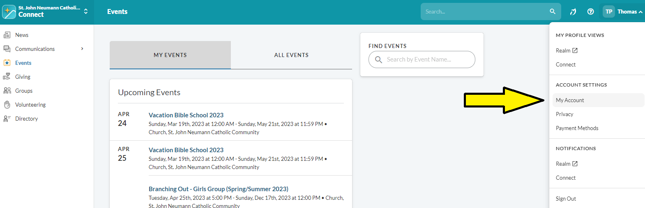
- Please verify the information for each family member. You can switch between family members by clicking on their names, highlighted in blue, on the right hand side of the screen.
- Click on the Events tab on the left side of the screen.
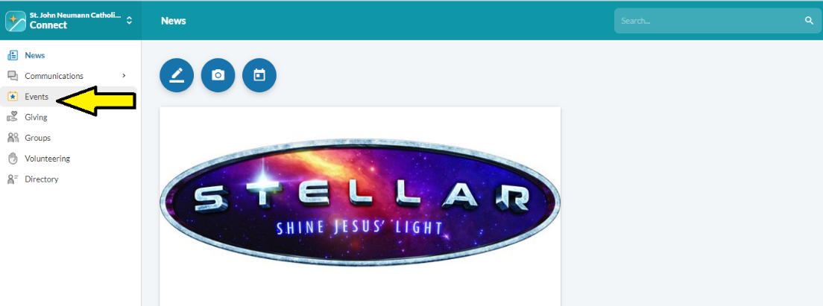

- Under All Events, you should see an event labeled “Faith Formation Registration 2023-2024” with the Sacred Heart of Jesus next to it. Click on this event.
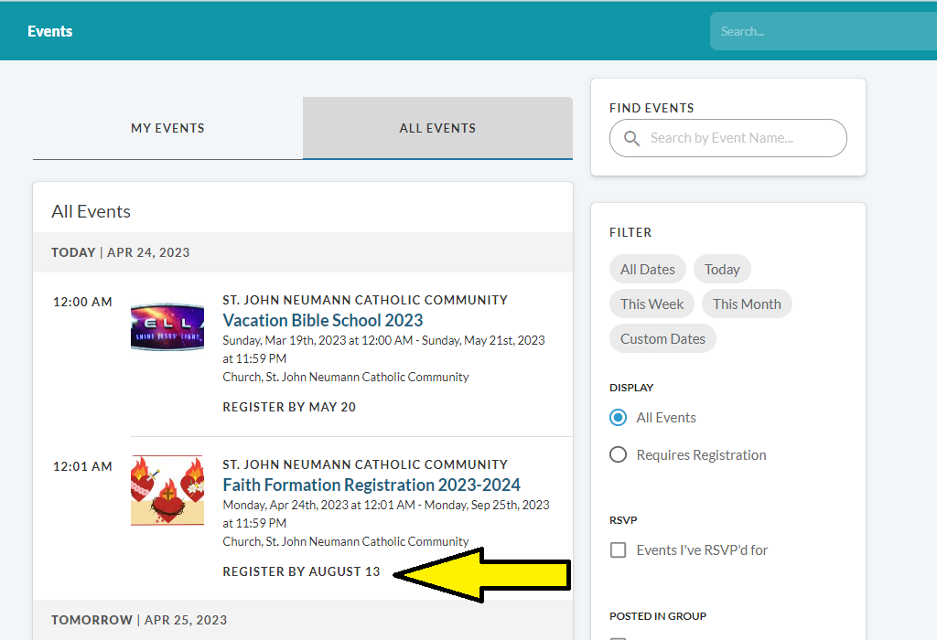

- Click on Register By August 13.
- On the right hand side, you’ll see all your family members. Check all children you will be registering. Do NOT select your name. Click Next.
- Answer all the questions for each child. It is extremely important that you select a grade and session carefully for each child. If you wish to change this later, you must cancel and re-register that child.
- You will be asked to pay online. Your online registration cannot be processed if you do not submit payment. If you are unable to pay for your children’s class registration or qualify for free tuition as a catechist during the upcoming school year, please contact SJN at reregistration@saintjn.org or 703-390-2343
- Please print your confirmation page for your records. You will also be e-mailed a confirmation to the email address(es) you provided.

