You can make a change to your registration details at any time. This includes all information except the grade and session. If you would like to change the grade and/or session of your registration, you will need to cancel your registration and reregister.
1. Login to your Realm account by going to: https://onrealm.org/StJohnNeumannCa/SignIn
2. Click on the Events tab on the left side of the screen. Scroll down to see Events I’ve Registered For.
3. Once you have clicked on the Faith Formation Registration 2023-2024 event, click on the Manage Registration button.
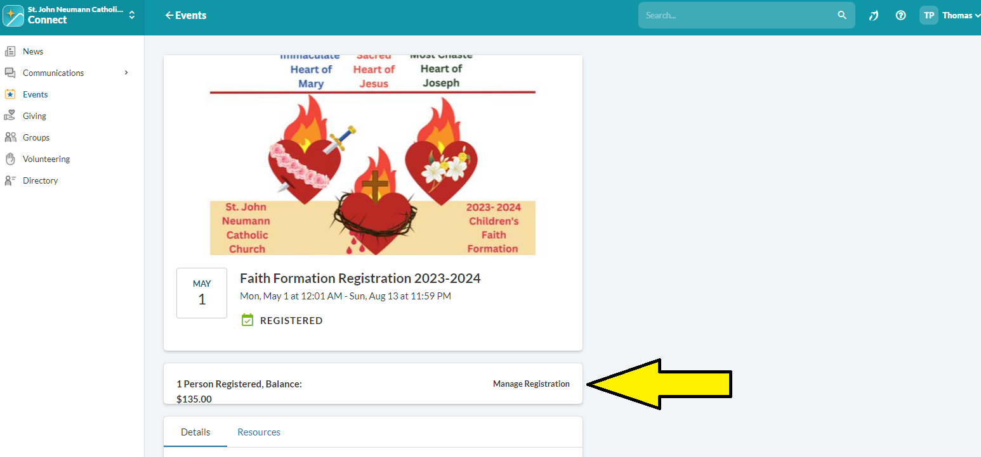
4. Click on the three dots next to the name of the registration you need to change, and select Edit Details.
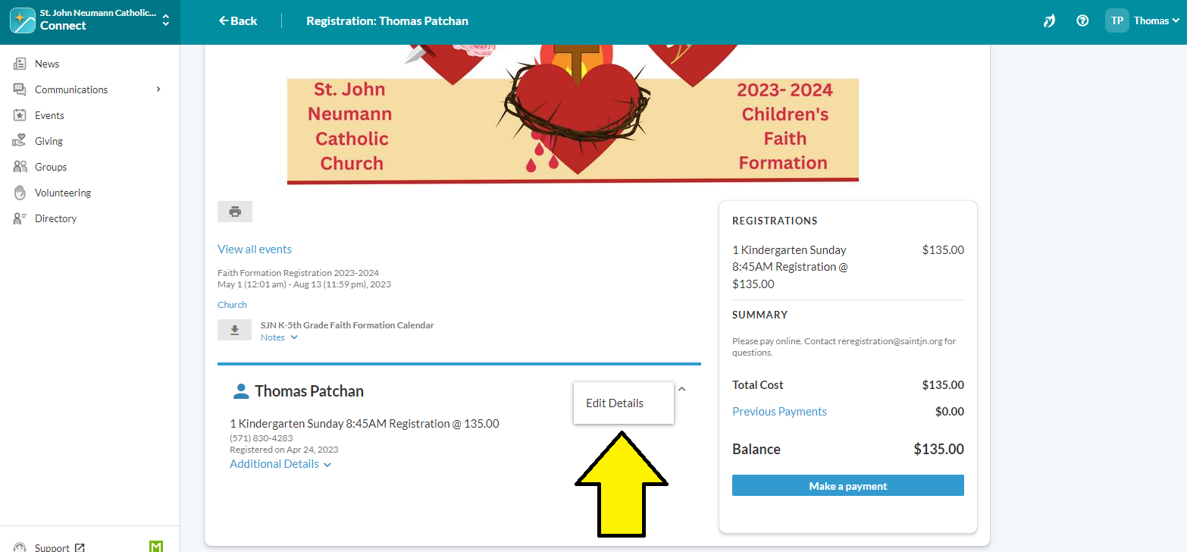
5. When finished editing, click the blue Next button.
6. Unfortunately, at this time parishioners are unable to edit the Registration Type (i.e. session & grade). If you wish to change the Registration Type, you must cancel the registration entirely for that child and re-register. You will receive a refund when you cancel (this will take approximately two weeks to process) and be asked to pay again when you re-register.
a. To re-register, press Edit Who’s Coming, then follow steps 8-11 in the Registration Directions on the SJN Children’s Faith Formation Webpage.

