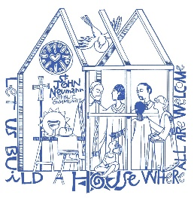
St. John Neumann Catholic Preschool

Media Release

Student Name_____________________________________________

Photos and videos of your child may be used for the following purposes. Names will not be used to identify children in photos or videos (with the exception of identifying materials used in the classroom such as job charts, attendance cards, etc.). Please initial next to the item that you agree for your child to be included in.

______ Class newsletters and emails sent from teachers to parents. Your child’s picture could be sent to the whole class with no identifying information.

______ Slide shows for preschool events

______ Class photo taken by a professional photographer

______ Parish Facebook page

______ Parish website

______ Parish bulletin

______ Each class will send out a class roster containing each child’s first and last name, mother’s first and last name, cell phone number and email address. If you do not initial this than just your child’s first name will be on the roster.

I give permission for SJNCP to use photos and/or videos of my child for the above purposes.

Parent Signature___________________________________________Date________________

Please note: Room parents will be given rosters will all cell phone numbers to be used to contact parents in the case of a school emergency.

