2023 Summer Camp Application
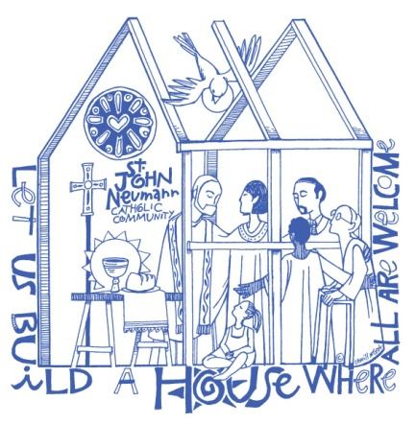
St. John Neumann Preschool
11900 Lawyers Rd., Reston, VA 20191
(703) 860-6158

Date of Application ____/_____/_____

Student’s Name ___________________________ _____________________ ______________ Sex _______
Last First Middle
Name student is to be called at camp _______________ Date of Birth ____/___/____ Age on 6/1/23________

Street Address ______________________________________________________________________________

City ___________________ State __________ Zip Code ______________

Allergies/ health problems/ or medications being taken? _____________________________________________

Does your child require an EPI-PEN? Yes _____ No _____

Does your child have any physical and/or emotional conditions that we should know about that would allow

us to better meet his/her needs? ________________________________________________________________

Does your child have an IEP or receive special services through Fairfax or Loudoun County? If yes, please

explain. ___________________________________________________________________________________

Parent/Guardian (Mother) ____________________________ ___________________
First Last
Phone: __________________ ____________________ __________________ Email ____________________
Home Cell Business
Street Address _______________________________________________________________________________

City _____________________ State _________ Zip Code ______________

Parent/Guardian (Father) ___________________________ _____________________
First Last
Phone: ________________ _____________________ ____________________ Email ___________________
Home Cell Business

Street Address _______________________________________________________________________________

City _____________________ State _________ Zip Code ______________

Emergency Contact (cannot be Parent or Guardian and is authorized to pick up child). Must list two.

Name __________________________ ________________________ Relationship ___________________
First Last

Phone ________________________ _________________________ ___________________
Home Cell Business

Name __________________________ ________________________ Relationship ___________________
First Last

Phone ________________________ _________________________ ___________________
Home Cell Business

Summer Camp 2023
The cost for each week of summer camp is $125.00. Partial weeks are not available. Camp hours are 9:30 am to 1:00 pm each day. All campers must be 2 ½ years old by June 1, 2023 and be fully potty trained. Please check the week(s) you would like your child to attend:

______Week 1: June 5 - 9 Nature Adventures

______ Week 2: June 12 - 16 STEAM Adventures

______ Week 3: June 19 – 23 Journey to Adventureland

Please mail or deliver application form and payment to:
St. John Neumann Catholic Church
Attention: Preschool Summer Camp
11900 Lawyers Rd.
Reston, VA 20191

All students who were not enrolled in the St. John Neumann Catholic Preschool for the 2022-2023 school year are required to submit a state of VA health and immunization form, a Permission for Emergency Care form and a media release (all available from the Preschool office). All students must bring a lunch and water bottle each day. A mid-morning snack will be provided.

Applications will be accepted on a First Come, First Served basis.

We will notify you by email once your application has been received and processed. Thank you!

Parent/Guardian ____________________________________________ Date ___________________________
Signature

