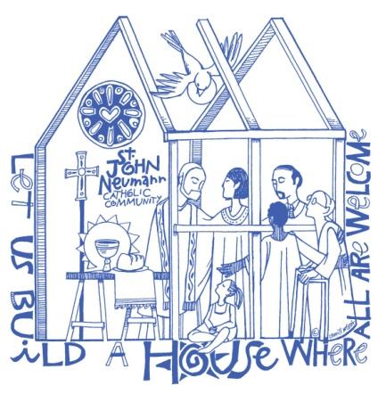
St. John Neumann Preschool
11900 Lawyers Rd.
Reston, VA 20191
(703) 860-6158

2022-2023 Application for Admission

Date of Application ____/_____/_____

Student’s Name ___________________________ _____________________ ______________ Sex _______
Last First Middle
Name student is to be called in School _______________ Date of Birth ____/___/____ Age on 9/30/22 ______

Street Address ______________________________________________________________________________

City ___________________ State __________ Zip Code ______________

How did you hear about our program? ___________________________________________________________

Has your child been baptized? Yes ______ No ______ If yes, name of church ____________________________

Allergies/ health problems/ or medications being taken? _____________________________________________

Does your child require an EPI-PEN? Yes _____ No _____

Does your child have any physical and/or emotional conditions that we should know about that would allow

us to better meet his/her needs?________________________________________________________________

Does your child have an IEP or receive special services through Fairfax or Loudoun County? If yes, please

explain. ___________________________________________________________________________________

Parent/Guardian (Mother) ____________________________ ___________________
First Last
Phone: __________________ ____________________ __________________ Email ____________________
Home Cell Business
Street Address _______________________________________________________________________________

City _____________________ State _________ Zip Code ______________

Occupation ______________________________ Employer ___________________________

Religion ________________________________ Registered Parish member of ___________________________

Parent/Guardian (Father) ___________________________ _____________________
First Last
Phone: ________________ _____________________ ____________________ Email ___________________
Home Cell Business

Street Address _______________________________________________________________________________

City _____________________ State _________ Zip Code ______________

Occupation ________________________ Employer __________________________
Religion ___________________________ Registered Parish member of ______________________________
Emergency Contact (cannot be Parent or Guardian and is authorized to pick up child). Must list two.

Name __________________________ ________________________ Relationship ___________________
First Last

Phone ________________________ _________________________ ___________________
Home Cell Business

Name __________________________ ________________________ Relationship ___________________
First Last

Phone ________________________ _________________________ ___________________
Home Cell Business

Programs offered in 2022-2023

_____ 2 ½ & 3 year old combined class (must be 2 ½ by Sept. 30, 2022) T/Th 9:15 am – 12:15 pm ($225/monthly)

______ 3 year old class (must be 3 by Sept. 30, 2022 and fully potty trained) M/W/F 9:15 am – 12:15 pm ($315 monthly)

______ 3 & 4 year old combined class (must be 3 by Sept. 30, 2022 and fully potty trained) M-Th 12:45 pm – 3:45 pm ($390 monthly)

______ 4 year old class (must be 4 by Sept. 30, 2022 and fully potty trained) M-F 9:15 am – 12:15 pm ($450 monthly)

We reserve the right to cancel any class if necessary due to Covid restrictions or if the class is not fully enrolled. Parents will be notified by June 15 and all fees refunded.
Please mail by USPS the application form to:
St. John Neumann Catholic Church
Attention: Preschool Registration
11900 Lawyers Rd.
Reston, VA 20191

You must include a check for $100 (refundable if you are not offered a spot) made out to St. John Neumann. You may return forms on the following dates:

Returning Preschool families – turn into Preschool office no earlier than Friday, January 14, 2022
Registered St. John Neumann Parishioners – postmarked no earlier than Friday, January 21, 2022.
Non St. John Neumann Parishioners – postmarked no earlier than Friday, January 28, 2022.

We will notify you by email once your application has been received and processed. Thank you!

Parents will be expected to provide before the first day of school (not applicable for returning students):
- a completed VA State School Entrance Health Form signed by the child’s doctor
- a current copy of the child’s immunizations
- an original Birth Certificate or Passport for verification

Parent/Guardian ____________________________________________ Date ___________________________
Signature
Demographic Data: The following information is optional and confidential. The information is used for our applications for Federal Grants and submissions to the National Catholic Educational Association’s annual statistical analysis of Catholic Schools in the United States. Please make a selection for both ethnicity and race.
Student’s ethnicity: ______ Hispanic/Latino ______ Other
Student’s race: ____ American Indian/Native Alaskan ____ Native Hawaiian/Pacific Islander ___ Black
___Asian ____White ____ Multi-Racial
St. John Neumann Preschool does not discriminate on the basis of race, color, gender, national origin, disability or religion in its admission policies. Catholic teachings are included in the curriculum.

