2021 Summer Camp Application
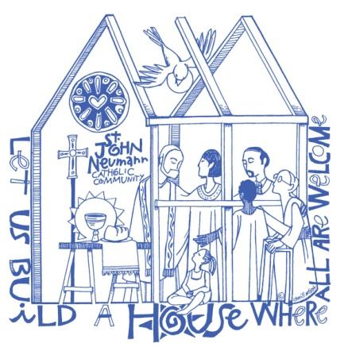
St. John Neumann Preschool
11900 Lawyers Rd., Reston, VA 20191
(703) 860-6158

Date of Application ____/_____/_____

Student’s Name ___________________________ _____________________ ______________ Sex _______
Last First Middle
Name student is to be called at camp _______________ Date of Birth ____/___/____ Age on 11/30/2020_____

Street Address ______________________________________________________________________________

City ___________________ State __________ Zip Code ______________

Allergies/ health problems/ or medications being taken? _____________________________________________

Does your child require an EPI-PEN? Yes _____ No _____

Does your child have any physical and/or emotional conditions that we should know about that would allow

us to better meet his/her needs? ________________________________________________________________

Does your child have an IEP or receive special services through Fairfax or Loudoun County? If yes, please

explain. ___________________________________________________________________________________

Parent/Guardian (Mother) ____________________________ ___________________
First Last
Phone: __________________ ____________________ __________________ Email ____________________
Home Cell Business
Street Address _______________________________________________________________________________

City _____________________ State _________ Zip Code ______________

Parent/Guardian (Father) ___________________________ _____________________
First Last
Phone: ________________ _____________________ ____________________ Email ___________________
Home Cell Business

Street Address _______________________________________________________________________________

City _____________________ State _________ Zip Code ______________

Emergency Contact (cannot be Parent or Guardian and is authorized to pick up child). Must list two.

Name __________________________ ________________________ Relationship ___________________
First Last

Phone ________________________ _________________________ ___________________
Home Cell Business

Name __________________________ ________________________ Relationship ___________________
First Last

Phone ________________________ _________________________ ___________________
Home Cell Business

Summer Camp 2021
The cost for each week of summer camp is $125.00. Partial weeks are not available. Camp hours are 9:30 am to 1:00 pm each day. All campers must be 2 years old by November 30,2020 and be fully potty trained. Please check the week(s) you would like your child to attend:

______Week 1: June 7 - 11 Fun & Fitness

______ Week 2: June 14 - 18 Outdoor Adventures

______ Week 3: June 21 – 25 Mad Scientist

Please mail or deliver application form and payment to:
St. John Neumann Catholic Church
Attention: Preschool Summer Camp
11900 Lawyers Rd.
Reston, VA 20191

All students who were not enrolled in the St. John Neumann Catholic Preschool for the 2019-2020 school year are required to fill out a Permission for Emergency Care form and a media release (available from the Preschool office). All students must bring a lunch each day. A mid-morning snack will be provided.

All campers will receive a camp T-shirt. Please circle desired size: Small Medium Large

We will notify you by email once your application has been received and processed. Thank you!

Parent/Guardian ____________________________________________ Date ___________________________
Signature

