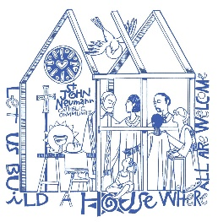
St. John Neumann Catholic Preschool

Media Release

Student Name_____________________________________________

Photos and videos of your child may be used for the following purposes. Names will not be used to identify children in photos or videos (with the exception of identifying materials used in the classroom such as job charts, attendance cards, etc.).

Class newsletters and emails sent from teachers to parents
Slide shows for preschool events
Bulletin boards
Class photo taken by a professional photographer
Parish Facebook page
Parish website
Parish bulletin

Please sign one of the following statements:

I DO give permission for SJNCP to use photos and/or videos of my child for the above purposes.

Parent Signature___________________________________________Date________________

OR

I DO NOT give permission for SJNCP to use photos and/or videos of my child for the above purposes.

Parent Signature___________________________________________Date________________

